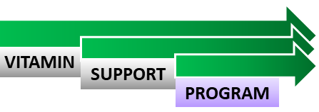
www.vitamin-sp.ca
SAMPLE: SINGLE COST OF VITAMINS

AGE | ITEM | COST | COST PER MONTH | SPONSOR COST | PHARMACY COST
0 to 1-Year | Enfamil | $17.99 – 2 months supply | $ 9.00 | $ 4.50 | $ 4.50
2 to 12-Years | Flintstones | $11:99 - 2 months supply | $ 6.00 | $ 3.00 | $ 3.00
13-years + | One-a-Day | $14.99 – 3 months supply | $ 5.00 | $2.50 | $2.50
SINGLE COST OF VITAMINS

AGE | ITEM | COST | COST PER MONTH | SPONSOR COST | PHARMACY COST
0 to 1-Year
2 to 12-Years
13-years +
MONTHLY COST: SPONSOR & PHARMACY

AGE | ITEM | COST | COST PER MONTH | NUMBER OF ITEMS | TOTAL COST | SPONSOR COST | PHARMACY COST
0 to 1-Year
2 to 12-Years
13-years +

